Internship Program Report By



**D.PRADEEP KUMAR**

**18481A0223**

**In association with**

Contents

Introduction 3

Program organiser 3

Courtesy 3

Program details 3

Internship program 3

3rd May2021: Introduction to EPC Industry 4

4th May2021: Engineering documentation for EPC projects 5

5th May2021: Engineering documentation for commands and formulae 6

7th May 2021: Engineering documentation for Electrical system design 6

10th May 2021: Engineering documentation for Typical diagrams 8

11th May 2021: Classification of Transformers and Generators 8

12th May 2021: Classification of Switchgare constructoin and power factor improvement 9

17th May 2021: Detailing about UPS system and Busducts 10

18th May 2021: Detailing about Motor Starters and Sizing of motors 11

19th May 2021: Describing about Earthing systems and Lighting Protection 12

20th May 2021: Lighting or illumination systems and calculartions 14

21st May 2021: Lighting or illumination systems using DIALUX software 15

24th May 2021: Cabling and their calculations and types 16

25th May 2021: Cabling calculations and Cable gland selection 17

28th May 2021: Load calculations and Transformer sizing calculations 18

29th May 2021: DG set calculations 19

2nd June 2021: Calculations of Earthing and Lighting protection 20

5th June 2021: Cable sizing and cable tray sizing calculations 21

Conclusion 22

Feedback 22

# Introduction

#### Internship program arranged by GUDLAVALLERU ENGINEERING COLLEGE in association with Smart Internz, Hyderabad for the benefit of 3rd /4th year EEE batch 2018-2022 on Electrical Detailed design Engineering for Oil& Gas, Power and Utility industrial sectors.

# Program organiser

#### Smart Bridge, Hyderabad.

#### Pioneer in organising Internships, knowledge workshops, debates, hackathons, technical sessions and Industrial Automation projects.



# Courtesy

Dr. Sri B. Dasu – HOD – EEE, GEC

Mr. Rama Krishna –Coordinator Mr. Ramesh V - Mentor

Mr. Vinay Kumar - System Support

Mr. Harikanth – Software/Technical Support

# Program details

#### Smart Internz program schedule: 4 weeks starting from 3rd May 2021 Daily schedule time shall be 4PM to 6.30PM

#### Mode of Classes: Online through ZOOM Presenter: Mr Ramesh V

# Internship program

#### We have been given the opportunity to learn and interact with industry experienced engineering specialist to learn the Electrical detailed design engineering for various industrial sectors.

## 3rd May2021: Introduction to EPC Industry

|  |  |  |  |
| --- | --- | --- | --- |
| 1 | EPC Industry & Electrical Detailed Engineering | EPC Industry | Introduction |
| Engineering | Types of Engineering |
| Procurement | Engineering role in procurement |
| Construction | Engineering role during construction |

### Topic details:

#### Engineering phases, Engineering deliverables (drawings & documents) list, Design Engineer role at various phases of project.

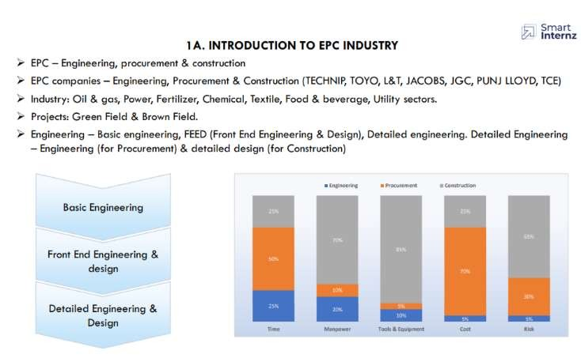

Here we get to know about EPC. EPC (Engineering, Procurement & Construction) is a prominent form of contracting agreement in the construction industry. EPC industry are companies who are involved in executing projects involving multiple engineering disciplines with overall responsibility for the performance of a “unit” or the whole plant.

## 4th May2021: Engineering documentation for EPC projects

|  |  |  |  |
| --- | --- | --- | --- |
| 2 | Electrical Design Documentation | Engineering Deliverables list | Sequence of deliverables |
| Detailed Engineering workflow | Detailed engineering process |
| Document transmission | Document submission and info exchange |
| Deliverables types | Different types of deliverables |

### Topic details:

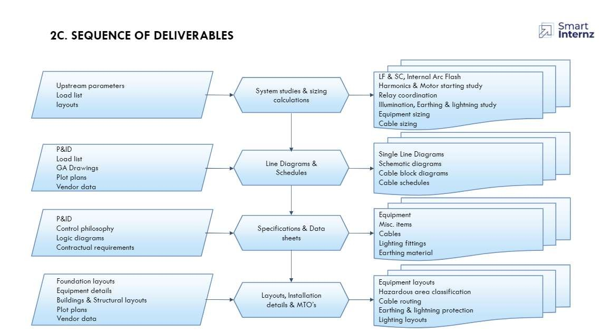

We learned that Engineering deliverables are the final product from project Engineering Management discipline and are the results from the Engineering and Project Engineering disciplines work.

The project and technical information must be exchanged between various domains and linearity must be maintained in the workflow. The sequence of deliverables must be identified and followed.

## 5th May2021: Engineering documentation for commands and formulae

|  |  |  |  |
| --- | --- | --- | --- |
| 3 | Document & Drawing tools | MS Word | Report / Calculations formats |
| MS Excel | Basic excel commands |
| AutoCAD | Basic line diagrams and layout  commends |

### Topic details:

MS Word, Excel, and Auto CAD Commands.

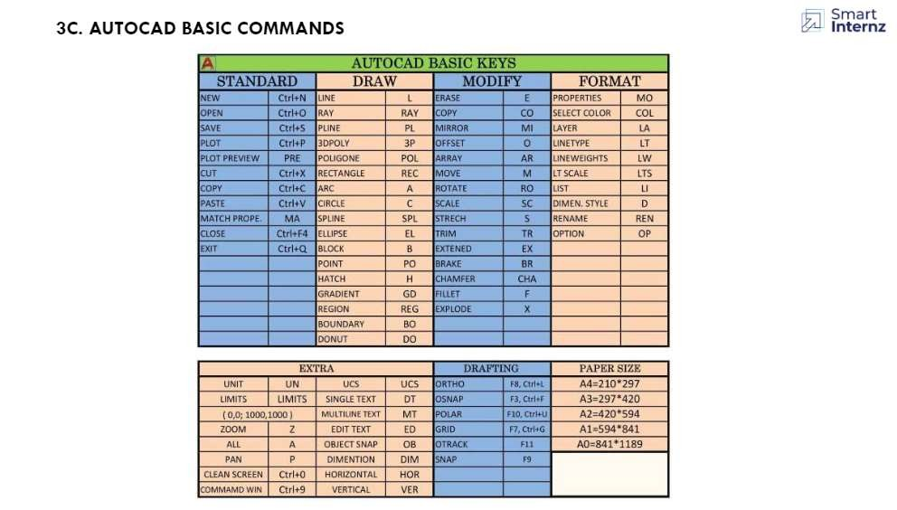

By using the commands, we can make document clearer and easier to understand. Shortcut keys reduces consumption of time and it is more flexible to create a document with shortcut keys rather than cursor usage.

AUTOCAD commands are used to make project. These helps us to know about AUTOCAD workspace.

## 7th May 2021: Engineering documentation for Electrical system design

|  |  |  |  |
| --- | --- | --- | --- |
| 4 | Estimation of Plant Electrical Load & SLD | Load List / Power balance | Load / Maximum demand calculation |
| Single Line Diagram | Development of SLD |
| Power Distribution system | Various power distribution systems |

### Topic details:

#### Overall plant description, approach to detailed design.

We observed that how to do a project and Sequence of approach to detail designand Overall plant distribution system. Importance of Single Line Diagram is described.

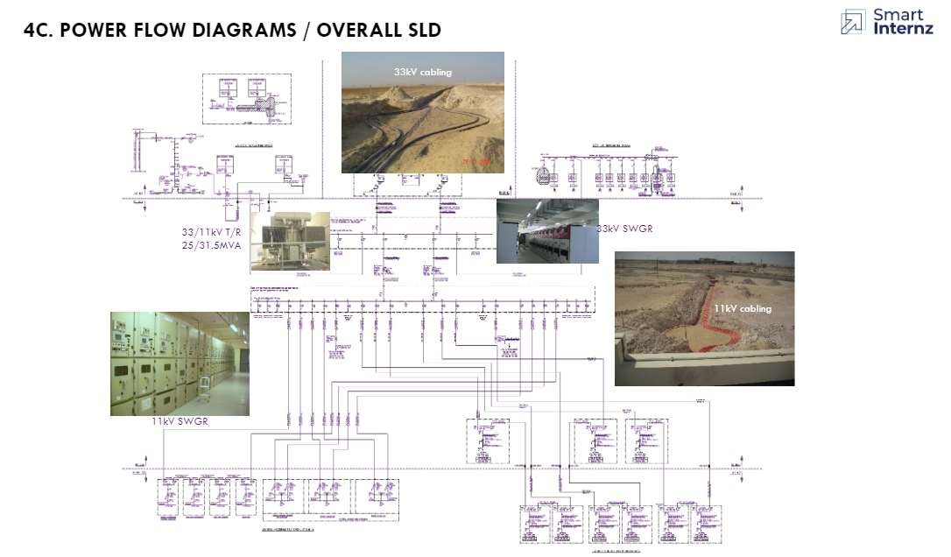

## 10th May 2021: Engineering documentation for Typical diagrams

|  |  |  |  |
| --- | --- | --- | --- |
| 5 | Electrical system design for typical diagrams | Load lists schedule | Power flow diagram |
| Single line diagram | Typical schematic diagram |

### Topic details:

Typical diagrams and Load calculations.

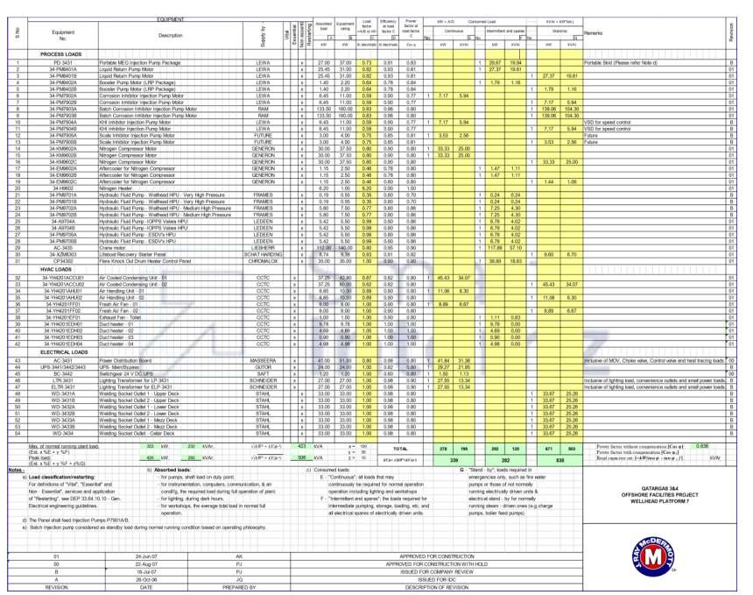

We learned how to do load calculations, draw and illustrate Typical diagrams, internal structure and also about the power flow diagram.

## 11th May 2021: Classification of Transformers and Generators

|  |  |  |  |
| --- | --- | --- | --- |
| 6 | Classification of Transformers and Generators | Different types of Transformers | Different types of Generators |

### Topic details:

Classification of Transformers and Generators.

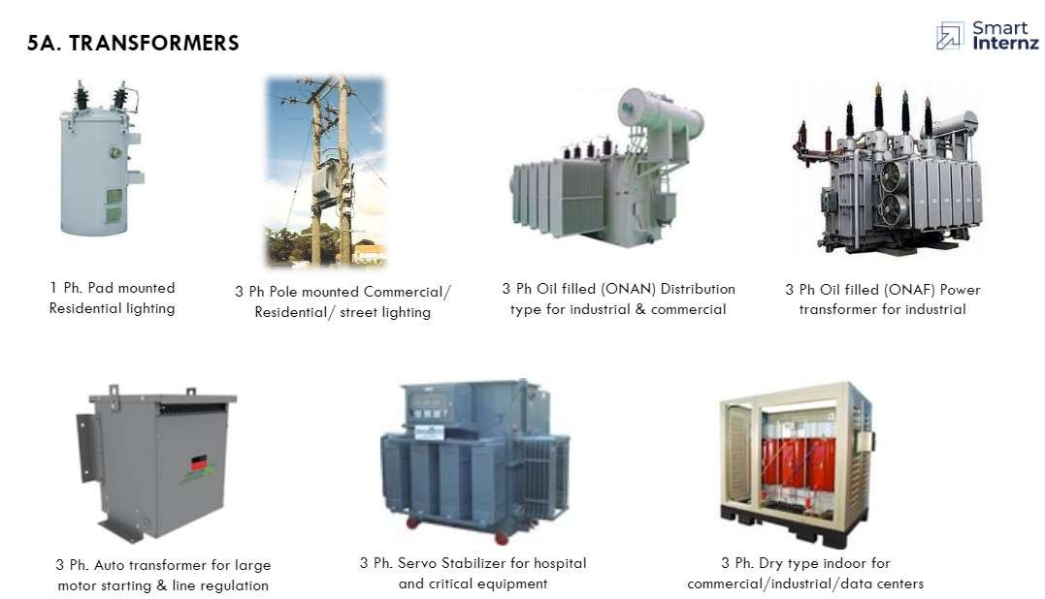

Transformers can be classified on different basis, like types of construction, types of cooling etc. Transformers are sized to carry the peak running load of all busses connected to them. In addition, feeders to and from power transformers shall be rated to carry full current at the maximum rating.

The packaged combination of a diesel engine, an alternator, and various ancillary devices such as base, canopy, sound attenuation, control systems, circuit breakers, jacket water heaters, starting systems etc., is referred to as a Diesel Generating Set or a DG Set in short.

12th May 2021: Classification of Switchgear, construction, and power factor improvement.

|  |  |  |  |
| --- | --- | --- | --- |
| 7 | Classification of Switchgear construction andpower factor improvement | Different types of Switchgear assembles | Power factor improvement |

### Topic details:

Classification of Switchgear construction and Power Factor Improvement.

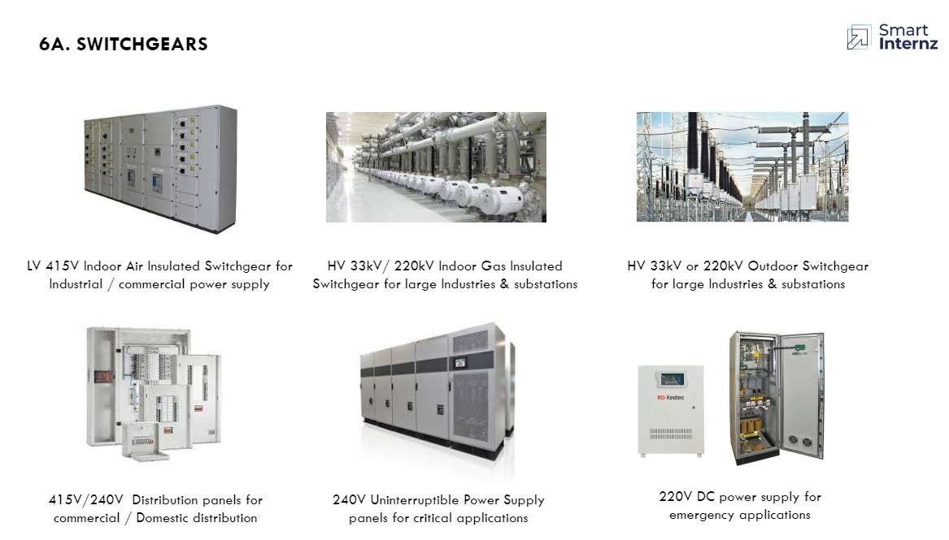

Switchgear includes switching & protecting devices like fuses, switches, CTs, VTs, relays, circuit breakers, etc. This device allows operating devices like electrical equipment, generators, distributors, transmission lines, etc. Once the short circuit occurs within the power system, then a huge current will flow through the devices. So that the equipment can be damaged & the interruption will occur to the operators. To overcome this problem, it is used to detect the fault in the power system to protect humans and equipment.

There are three types of switch gears namely LV (Low voltage), MV (Medium voltage) and HV (High voltage) Switchgear.

## 17th May 2021: Detailing about UPS system and Busducts.

|  |  |  |  |
| --- | --- | --- | --- |
| 8 | Detailing about  UPS system andBusducts | Uninterruptible power supply system | Busducts of the system |

### Topic details:

Power distribution of UPS system and Busducts.

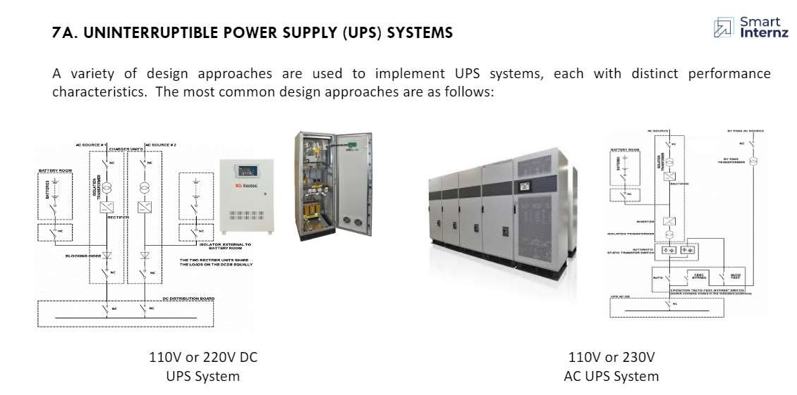

An uninterruptible power supply or uninterruptible power source (UPS) is an electrical apparatus that provides emergency power to a load when the input power source or mains power fails. It is a type of continual power system. UPS systems shall be two types:

* ACUPS–48V,110V,230VSinglephase&415Vthreephase
* DCUPS–24V48V,110V,220V

A sheet metal duct with aluminium or copper bus bars as conductor and used as are liable link for transferring power from one equipment to other at desired voltage levels, used as an alternate means for conducting electricity to cable bus and power cables. Bus ducts are classified into various types depending on its application they are:

* Phase separated Busducts.
* Segregated phase busducts
* Non-segregated phase busducts

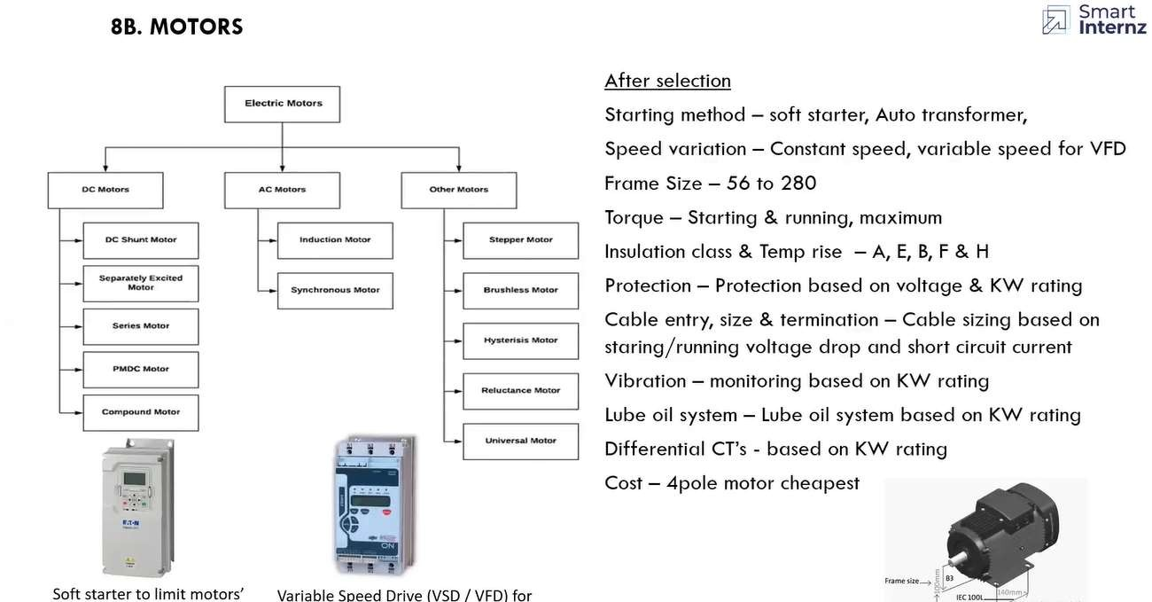

18th May 2021: Detailing about Earthing system and Lighting Protection.

|  |  |  |  |
| --- | --- | --- | --- |
| 9 | Detailing about Motor Starters and Sizing of motors | Motor starters and drives | Sizing and selection of motors |

### Topic details:

Detailing about Motor Starter and Sizing of motors and their selection.

The principal function of a motor starter is to start and stop the respective motor connected withspecially designed electromechanical switches which are similar in some ways to relays. The main difference between a relay and a starter is that a starter has overload protection for the motor that is missing in a relay.

Different types of motor starters are as follows:

* Direct-On-Line Starter
* Rotor Resistance Starter
* Stator Resistance Starter
* Auto Transformer Starter

##### Motor Sizing

LV motors - based on driven equipment shaft power + 10 -15% margin to select nearest standard size.

MV Motors - based on driven equipment shaft power + 5 -10% margin and rounded off to nearest 10s.

Voltage: 0.18 to 160kW LV, 200 to 1800kW 3.3/6.6KV, >2000 11kV also depends on availability

## 19th May 2021: Describing about Earthing systems and Lighting Protection.

|  |  |  |  |
| --- | --- | --- | --- |
| 10 | Describing aboutEarthing system and Lighting Protection. | Plant Earthing system | Lighting Protection materials |

### Topic details:

Describing about Earthing system and Lighting Protection.

.

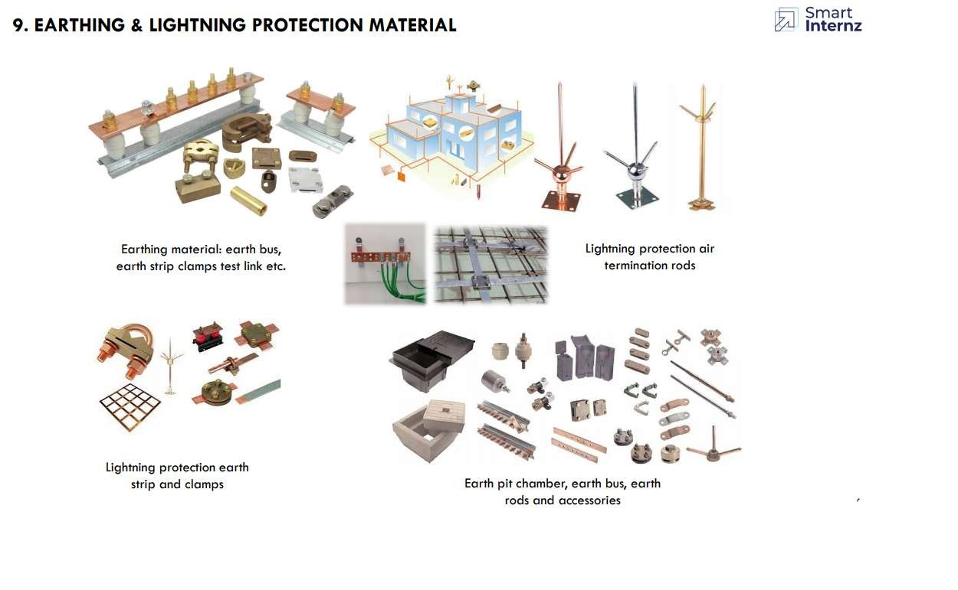

An **earthing system** or **grounding system** connects specific parts of an electric power

system with the ground, typically the Earth's conductive surface, for safety and functional purposes. The choice of earthing system can affect the safety and electromagnetic compatibility of the installation. Regulations for earthing systems vary considerably among countries, though most follow the recommendations of the International Electrotechnical Commission. Regulations may identify special cases for earthing in mines, in patient care areas, or in hazardous areas of industrial plants.

Inputs required: Lightning Protection calculations, Equipment layouts, Earthing layout. Applicable Standards: IS 2309: Protection of buildings and allied structures against lightning,

IS 3043: Code of practice for earthing.

Deliverables: Lightning Protection Layouts, BOQ. Installation details: Lightning arrestors, earth pits, earth flats.

20th May 2021: Lighting or illumination systems and calculations

|  |  |  |  |
| --- | --- | --- | --- |
| 11 | Lighting or Illuminationsystems andCalculations | Lighting or illumination systems | Lighting calculations |

### Topic details:

Lighting or Illumination systems and Calculations.

Lighting or Illumination systems are designed based purpose, colour rendering, criticality.

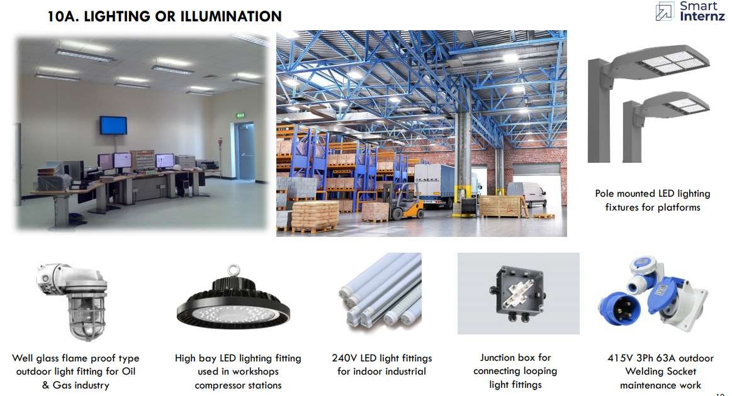

Selection of type of lighting fittings shall be as follows:

* Lighting fittings shall be of energy efficient type.
* LED/HPMV lamps shall be generally used for outdoor plant lighting. HPSV lamps shall be used for street lighting and area lighting. Now a days most of the outdoor lighting are designed LED type lamps.
* LED / Fluorescent lamps shall be used for indoor lighting for non-process building and control room. All chemical handling facilities shall be provided with chemical resistant fixtures.
* All ballasts shall be with copper winding and capacitor for power factor improvement (to 0.95) shall be provided with fixtures as applicable.
* DC critical lighting shall employ incandescent lamps

## 21st May 2021: Lighting or illumination systems using DIALUX software.

|  |  |  |  |
| --- | --- | --- | --- |
| 12 | Lighting or Illumination Using DIALUX software | Lighting or illumination systems | Operation of DIALUX software |

### Topic details:

Lighting or Illumination Calculations using DIALUX software.

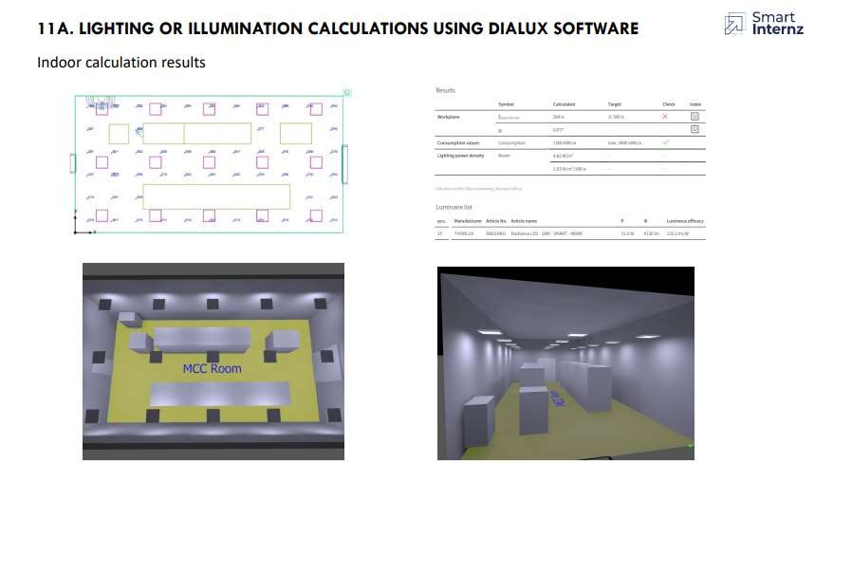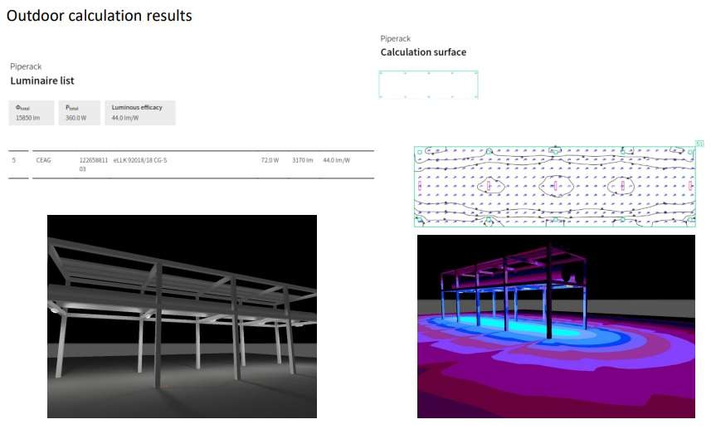

## 24th May 2021: Cabling and their calculations and types

|  |  |  |  |
| --- | --- | --- | --- |
| 13 | Cabling and their types and calculations | Cabling calculations | Types of cabling materials |

### Topic details:

Cabling and their types and calculations.

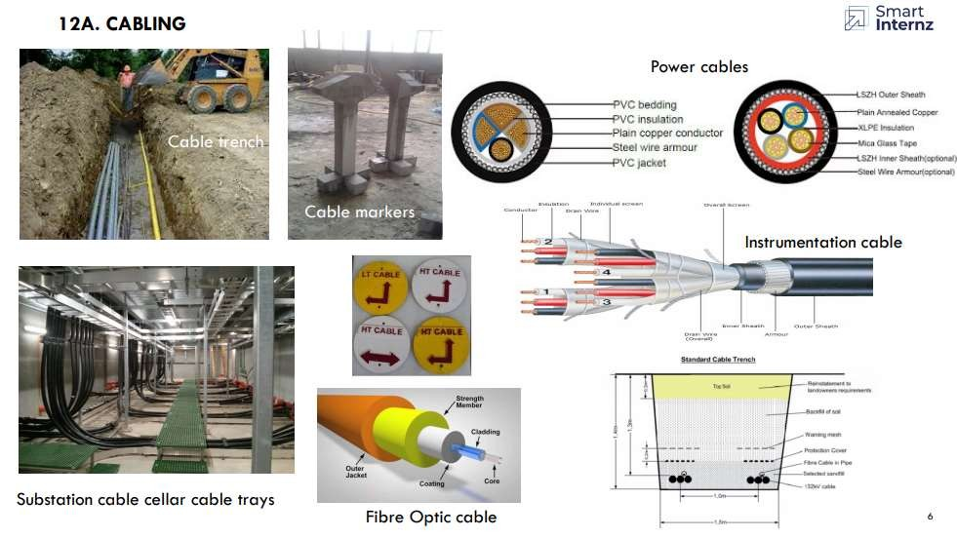

Electrical cables must be properly supported to relieve mechanical stresses on the conductors and protected from harsh conditions such as abrasion which might degrade the insulation.

Cable trays shall be generally loaded 60 to 70% leaving space for future use. Underground cabling shall be done in concrete cable trenches with cable trays in paved areas and directly buried with mandatory gap of 300mm between different systems of cables.

The desired minimum depth of laying from ground surface to the top of cable is as follows:

Medium voltage cables: 750 to 900 mm. High voltage cables: > 1000 mm.

Low voltage and control cables: 600 m.

Cables at road crossings: 1 m Cables at railway level crossings (measured from bottom of sleepers to the top of pipe): 1m.

Installation details: cable trays with supports, cables, cable tags.

## 25th May 2021: Cabling calculations and Cable gland selection.

|  |  |  |  |
| --- | --- | --- | --- |
| 14 | Cabling calculations and cable gland selection | Cabling calculations | Cable gland selection |

### Topic details:

Cable sizing calculation and cable gland selection.

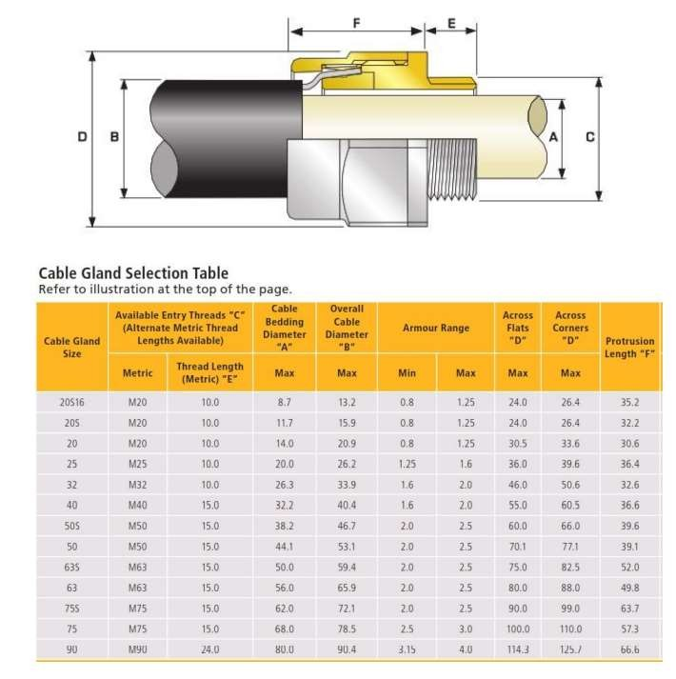

Cable glands are mechanical cable entry devices and can be constructed from metallic or non - metallic materials. Cable glands are used on all types of electrical power, control, instrumentation, data and telecommunications cables. They are used as a sealing and termination device to ensure that the characteristics of the enclosure which the cable enters can be maintained adequately.

## 28th May 2021: Load calculations and Transformer sizing calculations.

|  |  |  |  |
| --- | --- | --- | --- |
| 15 | Load calculations and TR calculations | Load calculations | TR calculations |

### Topic details:

#### List of electrical load calculations.

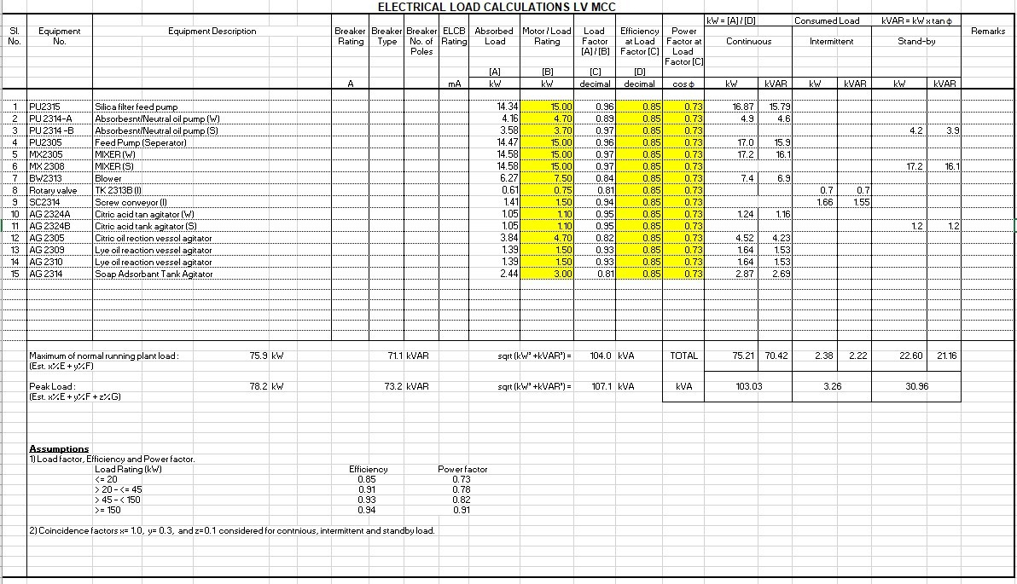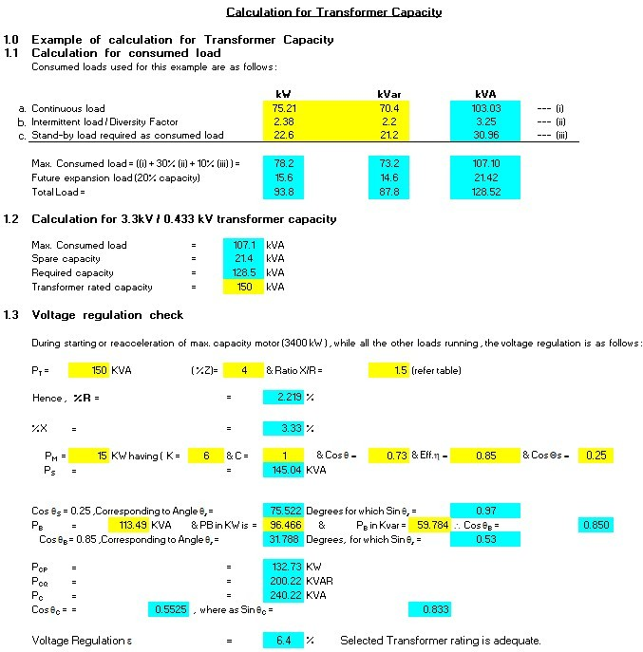

29th May 2021: DG set calculations.

DG set calculations

16

### Topic details:

#### Transformer and DG set calculations, types, sizing, or selections.

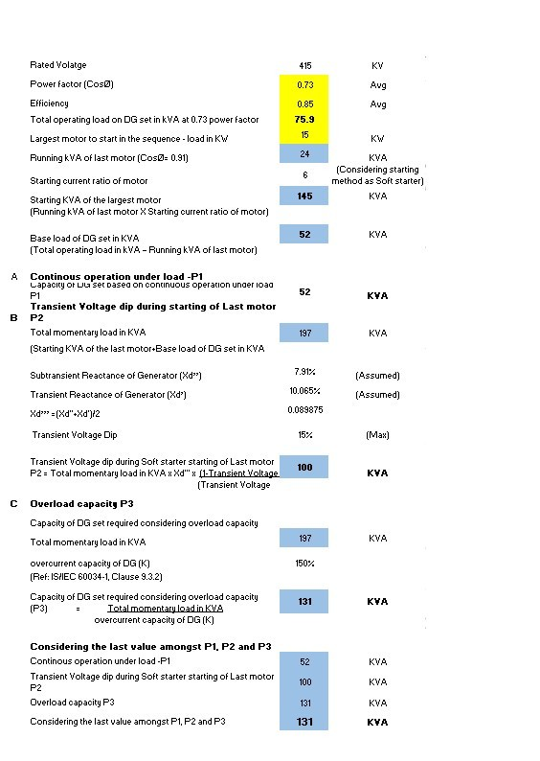

## 2nd June 2021: Calculations of Earthing and Lighting protection.

|  |  |  |  |
| --- | --- | --- | --- |
| 17 | Calculation of Earthing and Lighting protectioncalculations | Earthing calculations | Lighting protection calculation |

### Topic details:

Calculation of Earthing and Lighting protection calculations

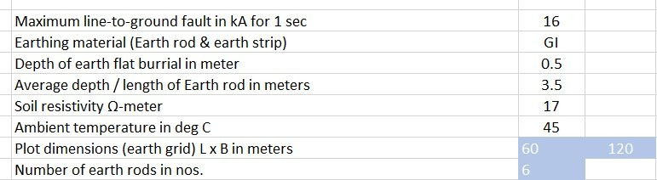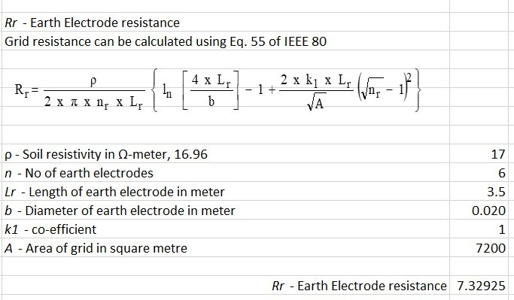

## 5th June 2021: Cable sizing and cable tray sizing calculations.

|  |  |  |  |
| --- | --- | --- | --- |
| 18 | Cable sizing and  cable tray sizingcalculations | Cable sizing calculations | Cable tray calculation |

### Topic details:

Cable sizinssg and cable tray sizing calculations for LV cables and MV/HV cables.

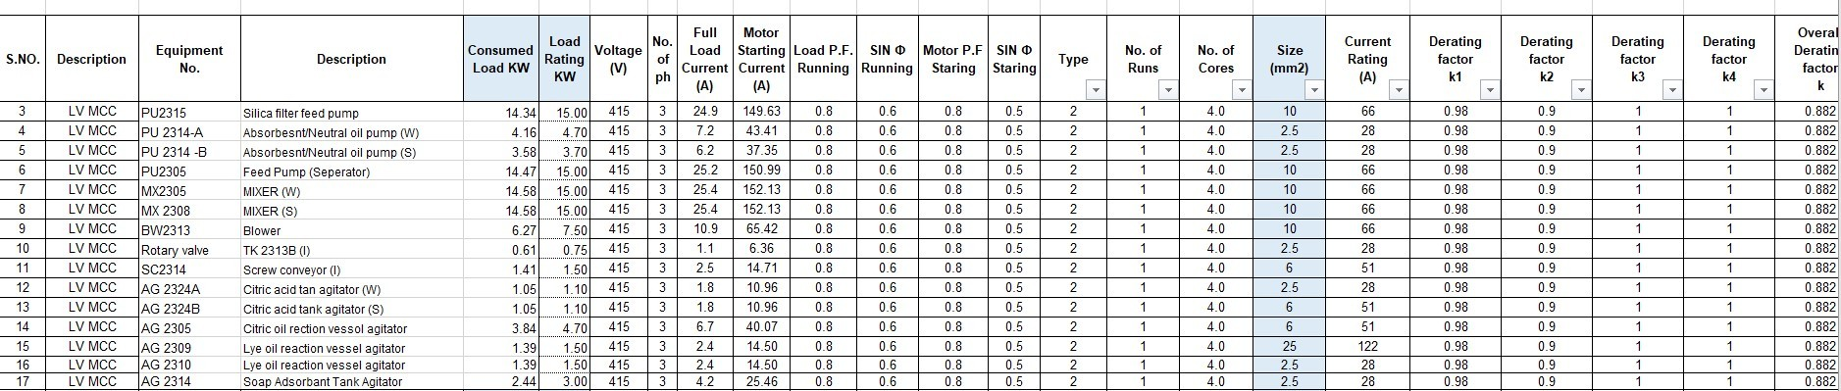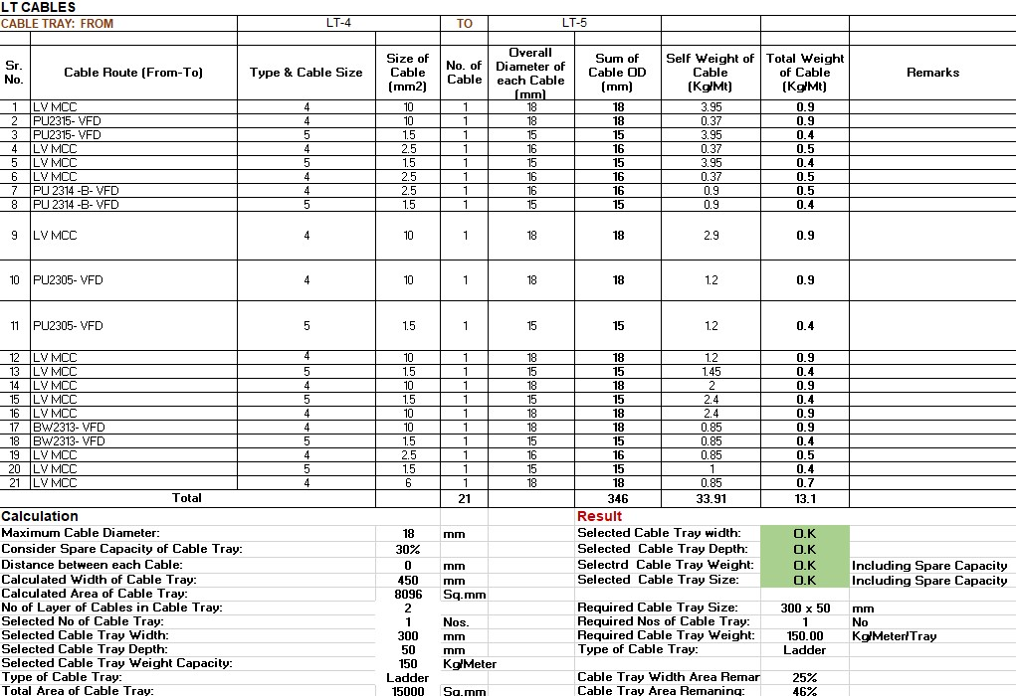

# Conclusion

#### We have been taught many aspects of engineering activities during the EPC stages for all electrical and related other disciplines also.

# Feedback

### Smart Bridge

Smart bridge conduct summer internships, workshops, debates,

hackathons, technical sessions etc. Its main motive is to bridge the gap between academy and industry.

### Method of conducting program.

Online platform (Zoom). Although it was online we had been explained all the concepts clearly through slides. Some software was introduced which is very much required for industry.

### Program highlights

Interaction of the trainer with students is very nice. Assignments make us understand better about the concepts, its limitations and calculations.

### Material

The day wise material was provided for us daily and we can access our classes in website which is very helpful for us.

### Benefits

We had a great opportunity to interact with the industry expert. It made us familiar with the industry environment.

Through this program we came to know how industry works and what are the tasks of every department to complete a project.

### Assignment-1

|  |  |  |  |  |  |  |  |  |  |  |  |  |  |  |  |  |  |  |  |  |
| --- | --- | --- | --- | --- | --- | --- | --- | --- | --- | --- | --- | --- | --- | --- | --- | --- | --- | --- | --- | --- |
| **ELECTRICAL LOAD CALCULATIONS LV MCC** | | | | | | | | | | | | | | | | | | | | |
|  |  |  |  |  |  | ELCB  Rating  mA |  | |  |  |  |  | kW = [A] / [D] |  | Consumed Load | | kVAR = kW | x tan φ | |  |
| Sl.  No. | Equipment  No. | Equipment Description | Breaker  Rating | Breaker  Type | Breaker  No. of Poles | Absorbed  Load | | Motor / Load  Rating | Load  Factor  [A] / [B] | Efficiency  at Load Factor [C] | Power  Factor at Load Factor [C] | Continuous | | Intermittent | | Stand-by | | | Remarks |
|  |  |  |  |  |  | [A] | | [B] | [C] | [D] |  |  | |  | |  | | |  |
|  |  |  | A |  |  | kW | | kW | decimal | decimal | cos φ | kW | kVAR | kW | kVAR | kW | | kVAR |  |
|  |  |  |  |  |  |  |  | |  |  |  |  |  |  |  |  |  | |  |  |
| 1 | PU2315 | Silica filter feed pump |  |  |  |  | 14.34 | | 15.00 | 0.96 | 0.85 | 0.73 | 16.87 | 15.79 |  |  |  | |  |  |
| 2 | PU 2314-A | Absorbesnt/Neutral oil pump (W) |  |  |  |  | 4.16 | | 4.70 | 0.89 | 0.85 | 0.73 | 4.9 | 4.6 |  |  |  | |  |  |
| 3 | PU 2314 -B | Absorbesnt/Neutral oil pump (S) |  |  |  |  | 3.58 | | 3.70 | 0.97 | 0.85 | 0.73 |  |  |  |  | 4.2 | | 3.9 |  |
| 4 | PU2305 | Feed Pump (Seperator) |  |  |  |  | 14.47 | | 15.00 | 0.96 | 0.85 | 0.73 | 17.0 | 15.9 |  |  |  | |  |  |
| 5 | MX2305 | MIXER (W) |  |  |  |  | 14.58 | | 15.00 | 0.97 | 0.85 | 0.73 | 17.2 | 16.1 |  |  |  | |  |  |
| 6 | MX 2308 | MIXER (S) |  |  |  |  | 14.58 | | 15.00 | 0.97 | 0.85 | 0.73 |  | |  |  | 17.2 | | 16.1 |  |
| 7 | BW2313 | Blower |  |  |  |  | 6.27 | | 7.50 | 0.84 | 0.85 | 0.73 | 7.4 | 6.9 |  |  |  | |  |  |
| 8 | Rotary valve | TK 2313B (I) |  |  |  |  | 0.61 | | 0.75 | 0.81 | 0.85 | 0.73 |  |  | 0.7 | 0.7 |  | |  |  |
| 9 | SC2314 | Screw conveyor (I) |  |  |  |  | 1.41 | | 1.50 | 0.94 | 0.85 | 0.73 |  | | 1.66 | 1.55 |  | |  |  |
| 10 | AG 2324A | Citric acid tan agitator (W) |  |  |  |  | 1.05 | | 1.10 | 0.95 | 0.85 | 0.73 | 1.24 | 1.16 |  |  |  | |  |  |
| 11 | AG 2324B | Citric acid tank agitator (S) |  |  |  |  | 1.05 | | 1.10 | 0.95 | 0.85 | 0.73 |  |  |  |  | 1.2 | | 1.2 |  |
| 12 | AG 2305 | Citric oil rection vessol agitator |  |  |  |  | 3.84 | | 4.70 | 0.82 | 0.85 | 0.73 | 4.52 | 4.23 |  |  |  | |  |  |
| 13 | AG 2309 | Lye oil reaction vessel agitator |  |  |  |  | 1.39 | | 1.50 | 0.93 | 0.85 | 0.73 | 1.64 | 1.53 |  |  |  | |  |  |
| 14 | AG 2310 | Lye oil reaction vessel agitator |  |  |  |  | 1.39 | | 1.50 | 0.93 | 0.85 | 0.73 | 1.64 | 1.53 |  |  |  | |  |  |
| 15 | AG 2314 | Soap Adsorbant Tank Agitator |  |  |  |  | 2.44 | | 3.00 | 0.81 | 0.85 | 0.73 | 2.87 | 2.69 |  |  |  | |  |  |
|  |  |  |  |  |  |  |  | |  |  |  |  |  |  |  |  |  | |  |  |
|  |  |  |  |  |  |  |  | |  |  |  |  |  |  |  |  |  | |  |  |
|  |  |  |  |  |  |  |  | |  |  |  |  |  |  |  |  |  | |  |  |
|  |  |  |  |  |  |  |  | |  |  |  |  |  |  |  |  |  | |  |  |
|  |  |  |  |  |  |  |  | |  |  |  |  |  |  |  |  |  | |  |  |
|  |  |  |  |  |  |  |  | |  |  |  |  |  |  |  |  |  | |  |  |
|  | Maximum of normal running plant load : 75.9 kW 71.1 | | | | kVAR |  | | sqrt (kW² +kVAR²) = | | 104.0 | kVA | TOTAL | 75.21 | 70.42 | 2.38 | 2.22 | 22.60 | | 21.16 |  |
| (Est. x%E + y%F) | | | |  |  | |  | |  |  |  |  |  |  |  |  | |  |
| Peak Load : 78.2 kW 73.2 | | | | kVAR |  | | sqrt (kW² +kVAR²) = | | 107.1 | kVA | kVA | 103.03 | | 3.26 | | 30.96 | | |
| (Est. x%E + y%F + z%G) | | | |  |  | |  | |  |  |  |  | |  | |  | | |
| **Assumptions** | | | |  |  | |  | |  |  |  |  |  |  | |  |  | |  |
| 1) Load factor, Efficiency and Power factor. | | | |  |  | |  | |  |  |  |  |  |  | |  |  | |  |
| Load Rating (kW) Efficiency | | | |  | Power factor | |  | |  |  |  |  |  |  | |  |  | |  |
| <= 20 0.85 | | | |  | 0.73 | |  | |  |  |  |  |  |  | |  |  | |  |
| > 20 - <= 45 0.91 | | | |  | 0.78 | |  | |  |  |  |  |  |  | |  |  | |  |
| > 45 - < 150 0.93 | | | |  | 0.82 | |  | |  |  |  |  |  |  | |  |  | |  |
| >= 150 0.94 | | | |  | 0.91 | |  | |  |  |  |  |  |  | |  |  | |  |
| 2) Coincidence factors x= 1.0, y= 0.3, and z=0.1 considered for contnious, intermittent and standby load. | | | |  |  | |  | |  |  |  |  |  |  | |  |  | |  |

1. load Calcs

**Assignment-2**

**Calculation for Transformer Capacity**

* 1. **Example of calculation for Transformer Capacity**
  2. **Calculation for consumed load**

Consumed loads used for this example are as follows :

* + 1. Continuous load
    2. Intermittent load / Diversity Factor
    3. Stand-by load required as consumed load

**kW kVar kVA**

75.21

2.38

22.6

70.4

2.2

21.2

--- (i)

103.03

3.25

30.96

--- (ii)

--- (iii)

|  |  |  |  |  |  |
| --- | --- | --- | --- | --- | --- |
| Max. Consumed load = ((i) + 30% (ii) + 10% (iii) ) = | 78.2 |  | 73.2 |  | 107.10 |
| Future expansion load (20% capacity) | 15.6 |  | 14.6 |  | 21.42 |
| Total Load = | 93.8 |  | 87.8 |  | 128.52 |

* 1. **Calculation for 3.3kV / 0.433 kV transformer capacity**

|  |  |  |  |  |
| --- | --- | --- | --- | --- |
|  | Max. Consumed load | = | 107.1 | kVA |
| Spare capacity | = | 21.4 | kVA |
| Required capacity | = | 128.5 | kVA |
| Transformer rated capacity | = | 150 | kVA |
| **1.3** | **Voltage regulation check** |  |  |  |

During starting or reacceleration of max. capacity motor (3400 kW ) , while all the other loads running , the voltage regulation is as follows : PT = 150 KVA ( %Z)= 4 & Ratio X/R = 1.5 (refer table)

Hence , **%R** = = 2.219 %

%X = = 3.33 %

PM = 15 KW having ( K = 6 & C = 1

& Cos θ =

0.73 & Eff.h = 0.85 & Cos Qs = 0.25

PS = = 145.044 KVA

Cos θS = 0.25 ,Corresponding to Angle θs = 75.5225 Degrees for which Sin qs =

0.97

PB = 113.489 KVA & PB in KW is = 96.4657 & PB in Kvar = 59.784 \ Cos θB = 0.850

Cos θB = 0.85 ,Corresponding to Angle θs = 31.7883 Degrees, for which Sin θs = 0.53

PCP = =

132.727

200.223

240.22

PCQ = =

PC = =

Cos θC = = 0.55252 , where as Sin θC =

KW KVAR KVA

0.833

Voltage Regulation e = 6.4 % Selected Transformer rating is adequate.

**Result:** During starting of max. capacity motor, while all other loads are running , the voltage regulation at Transformer secondary terminals shall be approx. 6.4% which meets the criteria to maintain less than 15% voltage regulation.

* 1. **Selection of rated capacity**

Hence 150kVA Transformer rating selected.

**Assignment-3**

|  |  |  |
| --- | --- | --- |
| **DG SIZING CALCULATIONS** |  | |
| **Design Data** |  |  |
| Rated Volatge | 415 | KV |
| Power factor (CosØ) | 0.73 | Avg |
| Efficiency | 0.85 | Avg |
| Total operating load on DG set in kVA at 0.73 power factor | **75.9** |  |
| Largest motor to start in the sequence - load in KW | 15 | KW |
| Running kVA of last motor (CosØ= 0.91) | 24 | KVA |
| Starting current ratio of motor Starting KVA of the largest motor  (Running kVA of last motor X Starting current ratio of motor)  Base load of DG set in KVA  (Total operating load in kVA – Running kVA of last motor)   1. **Continous operation under load -P1**   Capacity of DG set based on continuous operation under load P1   1. **Transient Voltage dip during starting of Last motor P2**   Total momentary load in KVA  (Starting KVA of the last motor+Base load of DG set in KVA  Subtransient Reactance of Generator (Xd’’) Transient Reactance of Generator (Xd’) Xd’’’ =(Xd"+Xd')/2  Transient Voltage Dip  Transient Voltage dip during Soft starter starting of Last motor  P2 = Total momentary load in KVA x Xd'" x (1-Transient Voltage Dip)  (Transient Voltage Dip)   1. **Overload capacity P3**   Capacity of DG set required considering overload capacity Total momentary load in KVA  overcurrent capacity of DG (K) (Ref: IS/IEC 60034-1, Clause 9.3.2)  Capacity of DG set required considering overload capacity (P3) = Total momentary load in KVA  overcurrent capacity of DG (K) | 6  **145**  **52**  **52**  197  7.91%  10.065%  0.089875  15%  **100**  197  150%  **131** | (Considering starting method as Soft starter)  KVA  KVA  **KVA**  KVA  (Assumed) (Assumed)  (Max)  **KVA**  KVA  **KVA** |
| **Considering the last value amongst P1, P2 and P3** |  |  |
| Continous operation under load -P1 | 52 | KVA |
| Transient Voltage dip during Soft starter starting of Last motor P2 | 100 | KVA |
| Overload capacity P3 | 131 | KVA |
| Considering the last value amongst P1, P2 and P3 | **131** | **KVA** |
| Hence, Existing Generator 131 KVA is adequate to cater the loads as per re- scheduled loads |  |  |
| NOTE:VOLTAGE DIP CONSIDERED - 15% |  |  |

**Assignment-4 Earthing Calculations**

|  |  |  |
| --- | --- | --- |
|  | **3** |  |
| Maximum line-to-ground fault in kA for 1 sec | 16 |
| Earthing material (Earth rod & earth strip) | GI |
| Depth of earth flat burrial in meter | 0.5 |
| Average depth / length of Earth rod in meters | 3.5 |
| Soil resistivity Ω-meter | 17 |
| Ambient temperature in deg C | 45 |
| Plot dimensions (earth grid) L x B in meters | 60, | 120 |
| Number of earth rods in nos. | 6 |  |
| Earth electrode sizing:  Ac - Required conductor cross section in sq.mm |  |  |

|  |  |
| --- | --- |
| αr - Thermal co-efficient of resistivity, at 20 oC | 0.0032 |
| ρr - Resistivity of ground conductor at 20 oC | 20.10 |
| Ta - Ambient Temperature is °C | 50 |
| Il-g - RMS fault current in kA = 50 KA | 14 |
| tc - Short circuit current duration sec | 1 |
| Thermal capacity factor, TCAP J/(cm3.oC) | 3.93 |
| Tm - Maximum allowable temperature for copper conductor, in oC | 419 |
| K0 - Factor at oC | 293 |
| The data taken from IEEE 80-2000, Clause 11.3, Table-1 for clad steel rod: |  |
| 14 = Ac * | 0.123 |
| Ac - Required conductor cross section in sq.mm | 114 |
| Earth rod dia in mm | 12 |
| Earth rod dia (including 25% corrosion allowance) in mm | 15 |

Earth flat sizing:

Ac - Required conductor cross section in sq.mm

|  |  |
| --- | --- |
| αr - Thermal co-efficient of resistivity, at 20 oC | 0.0032 |
| ρr - Resistivity of ground conductor at 20 oC | 20.10 |
| Ta - Ambient Temperature is °C | 50 |
| Il-g - RMS fault current in kA = 50 KA | 14 |
| tc - Short circuit current duration sec | 1 |
| Thermal capacity factor, TCAP J/(cm3.oC) | 3.93 |
| Tm - Maximum allowable temperature for copper conductor, in oC | 419 |
| K0 - Factor at oC | 293 |
| The data taken from IEEE 80-2000, Clause 11.3, Table-1 for clad steel rod: |  |
| 14 = Ac * | 0.123 |
| Ac - Required conductor cross section in sq.mm | 114 |
| Earth flat area in mm | 12 |
| Earth flat area (including 25% corrosion allowance) in mm | 15 |
| Selected flat size W * Thk in sq mm | 20 |

*Rg* - Grid resistance

Grid resistance can be calculated using Eq. 52 of IEEE 80

⇦ 1 1 ⬆

1 ✓⇦

Rg =ρ L + ⬇1 + ☒

20 x A ⬇ 1 + h 20 /A ✗⇦☑

ρ - Soil resistivity in Ω-meter= 17

L - Total buried length of ground conductor in meter #VALUE! h - Depth of burial in meter 0.5

A - Grid area in sq. meter #VALUE!

*Rg* - Grid resistance #VALUE!

*Rr* - Earth Electrode resistance

Grid resistance can be calculated using Eq. 55 of IEEE 80

R = ρ ⇦ l

⬆ 4 x Lr   1 + 2 x k1 x Lr ( n  1)2 ✓⇦

r 2 x π x n x L  n ⬇ b  r ☒

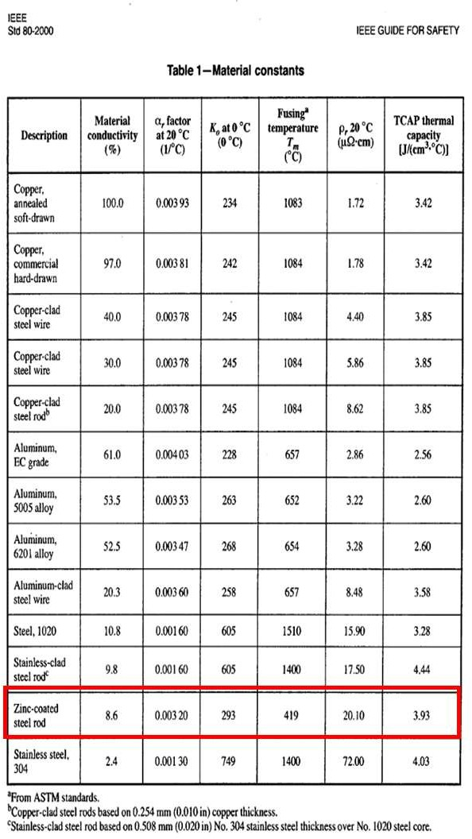

r r ⇦  ✗ A ⇦☑

ρ - Soil resistivity in Ω-meter, 16.96 17

*n* - No of earth electrodes 6

*Lr* - Length of earth electrode in meter 3.5

*b* - Diameter of earth electrode in meter 0.020

*k1* - co-efficient 1

*A* - Area of grid in square metre #VALUE!

*Rr* - Earth Electrode resistance #VALUE!

Grounding system resistance

Grounding system resistance can be calculated using equation 53 of IEEE 80 as follows:

Rg x R 2  Rm2

Rs = R + R  2R

g 2 m

Rm - Mutual ground resistance between the group of ground conductors, Rg and group of electrodes, Rr in Ω. Neglected Rm, since this is for homogenous soil

*Rs* - Total earthing system resistance #VALUE! Ohms The calculated resistance grounding system is less than the allowable 1 Ω value.

Location

Building

Type of Building Building Length (L) Building breadth (W) Building Height (H)

**Assignment-5 Lightning Protection Calculations**

**3**

Visakhapatnam Concrete, Hospital Flat Roofs (a)

20

9

8

**Risk Factor Calculation**

**1 Collection Area (Ac)**

Ac

=

(L*W) + (2*L*H) + (2*W*H) + (3.14*H*H)

844.96

**2 Probability of Being Struck (P)**

P =

Ac * Ng * 10

-6

0.000929456

1. **Overall weighing factor**
   1. Use of structure (A)
   2. Type of construction (B)
   3. Contents or consequential effects (C)
   4. Degree of isolation (D)
   5. Type of country (E)

Wo - Overall weighing factor

1. **Overall Risk Factor**

Po

Po Pa

=

=

=

=

=

=

=

=

=

1.7

0.4

1.7

1.0

0.3

A * B * C * D * E 0.347

P * Wo 0.000322335

10⁻⁵

As per clause no. 9.7 of BS- 6651, suggested acceptable risk factor ( Po) has been taken as 10-5

Since Po > Pa lightning protection required.

**5 Air Terminations**

Size of Down conductor

=

20 X 2.5 mm Galvanized Steel Strip

(As per BS6651, lightning currents have very short duration, therefore thermal factors

are of little consequence in deciding the cross-section of the conductor. The minimum size of Down conductors - 20mm X 2.5 mm Galvanized Steel Strip)

|  |  |  |  |
| --- | --- | --- | --- |
| Perimeter of the building | =  = | 2(L+W)  58 | Mts. |
| **6 Down Conductors** |  |  |  |
| Perimeter of building | = | 58 | Mts. |
| No. of down conductors based on perimeter | = | 3 | Nos. |
| Hence 3 nos. of Down conductors have been selected. |  |  |  |

**Assignment-6 Cable Sizing Calculations**

|  |  |  |  |  |  |  |  |  |  |  |  |  |  |  |  |  |  |  |  |  |  |  |  |  |  |  |  |  |  |  |  |  |  |  |
| --- | --- | --- | --- | --- | --- | --- | --- | --- | --- | --- | --- | --- | --- | --- | --- | --- | --- | --- | --- | --- | --- | --- | --- | --- | --- | --- | --- | --- | --- | --- | --- | --- | --- | --- |
| **S.NO.** | **Description** | **Equipment No.** | **Description** | **Consumed Load KW** | **Load Rating KW** | **Voltage (V)** | **No. of ph** | **Full Load Current (A)** | **Motor Starting Current (A)** | **Load P.F. Running** | **SIN Φ**  **Running** | **Motor P.F Staring** | **SIN Φ**  **Staring** | **Type** | **No. of Runs** | **No. of Cores** | **Size (mm2)** | **Current Rating (A)** | **Derating factor k1** | **Derating factor k2** | **Derating factor k3** | **Derating factor k4** | **Overall Derating factor**  **k** | **Derated Current (A)** | **Cable Length (M)** | **Cable Resistance (Ohms/kM)** | **Cable Reactance (Ohms/kM)** | **Voltage drop (Running) (V)** | **Voltage drop (Running) (%)** | **Voltage drop (Starting) (V)** | **Voltage drop (starting) (%)** | **Cable size result** | **OD of Cable (mm)** | **Gland size** |
| 3 | LV MCC | PU2315 | Silica filter feed pump | 14.34 | 15.00 | 415 | 3 | 24.9 | 149.63 | 0.8 | 0.6 | 0.8 | 0.5 | 2 | 1 | 4.0 | 10 | 66 | 0.98 | 0.9 | 1 | 1 | 0.882 | 58.2 | 95 | 2.3400 | 0.0852 | 7.89 | 1.90 | 47.14 | 11.36 | OK | 18 | 20 |
| 4 | LV MCC | PU 2314-A | Absorbesnt/Neutral oil pump (W) | 4.16 | 4.70 | 415 | 3 | 7.2 | 43.41 | 0.8 | 0.6 | 0.8 | 0.5 | 2 | 1 | 4.0 | 2.5 | 28 | 0.98 | 0.9 | 1 | 1 | 0.882 | 24.7 | 95 | 9.4800 | 0.1007 | 9.10 | 2.19 | 54.53 | 13.14 | OK | 16 | 20s |
| 5 | LV MCC | PU 2314 -B | Absorbesnt/Neutral oil pump (S) | 3.58 | 3.70 | 415 | 3 | 6.2 | 37.35 | 0.8 | 0.6 | 0.8 | 0.5 | 2 | 1 | 4.0 | 2.5 | 28 | 0.98 | 0.9 | 1 | 1 | 0.882 | 24.7 | 60 | 9.4800 | 0.1007 | 4.95 | 1.19 | 29.64 | 7.14 | OK | 16 | 20s |
| 6 | LV MCC | PU2305 | Feed Pump (Seperator) | 14.47 | 15.00 | 415 | 3 | 25.2 | 150.99 | 0.8 | 0.6 | 0.8 | 0.5 | 2 | 1 | 4.0 | 10 | 66 | 0.98 | 0.9 | 1 | 1 | 0.882 | 58.2 | 85 | 2.3400 | 0.0852 | 7.12 | 1.72 | 42.56 | 10.25 | OK | 18 | 20s |
| 7 | LV MCC | MX2305 | MIXER (W) | 14.58 | 15.00 | 415 | 3 | 25.4 | 152.13 | 0.8 | 0.6 | 0.8 | 0.5 | 2 | 1 | 4.0 | 10 | 66 | 0.98 | 0.9 | 1 | 1 | 0.882 | 58.2 | 75 | 2.3400 | 0.0852 | 6.33 | 1.53 | 37.84 | 9.12 | OK | 18 | 20s |
| 8 | LV MCC | MX 2308 | MIXER (S) | 14.58 | 15.00 | 415 | 3 | 25.4 | 152.13 | 0.8 | 0.6 | 0.8 | 0.5 | 2 | 1 | 4.0 | 10 | 66 | 0.98 | 0.9 | 1 | 1 | 0.882 | 58.2 | 105 | 2.3400 | 0.0852 | 8.87 | 2.14 | 52.97 | 12.76 | OK | 18 | 20s |
| 9 | LV MCC | BW2313 | Blower | 6.27 | 7.50 | 415 | 3 | 10.9 | 65.42 | 0.8 | 0.6 | 0.8 | 0.5 | 2 | 1 | 4.0 | 10 | 66 | 0.98 | 0.9 | 1 | 1 | 0.882 | 58.2 | 100 | 2.3400 | 0.0852 | 3.63 | 0.88 | 21.69 | 5.23 | OK | 18 | 20s |
| 10 | LV MCC | Rotary valve | TK 2313B (I) | 0.61 | 0.75 | 415 | 3 | 1.1 | 6.36 | 0.8 | 0.6 | 0.8 | 0.5 | 2 | 1 | 4.0 | 2.5 | 28 | 0.98 | 0.9 | 1 | 1 | 0.882 | 24.7 | 100 | 9.4800 | 0.1007 | 1.40 | 0.34 | 8.42 | 2.03 | OK | 16 | 20s |
| 11 | LV MCC | SC2314 | Screw conveyor (I) | 1.41 | 1.50 | 415 | 3 | 2.5 | 14.71 | 0.8 | 0.6 | 0.8 | 0.5 | 2 | 1 | 4.0 | 6 | 51 | 0.98 | 0.9 | 1 | 1 | 0.882 | 45.0 | 75 | 3.9400 | 0.0902 | 1.02 | 0.25 | 6.11 | 1.47 | OK | 18 | 20 |
| 12 | LV MCC | AG 2324A | Citric acid tan agitator (W) | 1.05 | 1.10 | 415 | 3 | 1.8 | 10.96 | 0.8 | 0.6 | 0.8 | 0.5 | 2 | 1 | 4.0 | 2.5 | 28 | 0.98 | 0.9 | 1 | 1 | 0.882 | 24.7 | 110 | 9.4800 | 0.1007 | 2.66 | 0.64 | 15.94 | 3.84 | OK | 16 | 20s |
| 13 | LV MCC | AG 2324B | Citric acid tank agitator (S) | 1.05 | 1.10 | 415 | 3 | 1.8 | 10.96 | 0.8 | 0.6 | 0.8 | 0.5 | 2 | 1 | 4.0 | 6 | 51 | 0.98 | 0.9 | 1 | 1 | 0.882 | 45.0 | 75 | 3.9400 | 0.0902 | 0.76 | 0.18 | 4.55 | 1.10 | OK | 18 | 20 |
| 14 | LV MCC | AG 2305 | Citric oil rection vessol agitator | 3.84 | 4.70 | 415 | 3 | 6.7 | 40.07 | 0.8 | 0.6 | 0.8 | 0.5 | 2 | 1 | 4.0 | 6 | 51 | 0.98 | 0.9 | 1 | 1 | 0.882 | 45.0 | 105 | 3.9400 | 0.0902 | 3.89 | 0.94 | 23.30 | 5.61 | OK | 18 | 20 |
| 15 | LV MCC | AG 2309 | Lye oil reaction vessel agitator | 1.39 | 1.50 | 415 | 3 | 2.4 | 14.50 | 0.8 | 0.6 | 0.8 | 0.5 | 2 | 1 | 4.0 | 25 | 122 | 0.98 | 0.9 | 1 | 1 | 0.882 | 107.6 | 85 | 0.9300 | 0.0816 | 0.28 | 0.07 | 1.68 | 0.40 | OK | 22 | 32 |
| 16 | LV MCC | AG 2310 | Lye oil reaction vessel agitator | 1.39 | 1.50 | 415 | 3 | 2.4 | 14.50 | 0.8 | 0.6 | 0.8 | 0.5 | 2 | 1 | 4.0 | 2.5 | 28 | 0.98 | 0.9 | 1 | 1 | 0.882 | 24.7 | 95 | 9.4800 | 0.1007 | 3.04 | 0.73 | 18.22 | 4.39 | OK | 16 | 20s |
| 17 | LV MCC | AG 2314 | Soap Adsorbant Tank Agitator | 2.44 | 3.00 | 415 | 3 | 4.2 | 25.46 | 0.8 | 0.6 | 0.8 | 0.5 | 2 | 1 | 4.0 | 2.5 | 28 | 0.98 | 0.9 | 1 | 1 | 0.882 | 24.7 | 65 | 9.4800 | 0.1007 | 3.65 | 0.88 | 21.88 | 5.27 | OK | 16 | 20s |

Basis:

* + 1. Overall derating factor k = k1 x k2 x k3 x k4

K1=Rating factor for variation in air/ground temperature

K2=Rating factor for depth of laying

K3=Rating factor for spacing between two circuits

K4=Rating factor for variation in thermal resistivity of the soil

* + 1. LT Motors : Running Voltage Drop = 3%, Starting Voltage Drop = 15%
    2. Cable type:

TYPE 1: Al Conductor, XLPE Insulated, Armoured, PVC outer sheathed TYPE 2: Cu Conductor, XLPE Insulated, Armoured, PVC outer sheathed

* + 1. Effect of Frequency Variation ± 5%
    2. Combined Effect of Voltage & Frequency Variation ±10%

**1**

**ASSIGNMENT-7**

|  |  |  |  |  |  |  |  |  |  |
| --- | --- | --- | --- | --- | --- | --- | --- | --- | --- |
| **Cable Tray Sizing** | | | | | | | | | |
| **LT CABLES** | | | | | | | | | |
| **CABLE TRAY: FROM** | | LT-4 | | **TO** | LT-5 | |  |  |  |
|  |  |  |  |  |  |  |  |  |  |
| **Sr.**  **No.** | **Cable Route (From-To)** | **Type & Cable Size** | **Size of Cable (mm2)** | **No. of Cable** | **Overall Diameter of each Cable**  **(mm)** | **Sum of Cable OD**  **(mm)** | **Self Weight of Cable (Kg/Mt)** | **Total Weight of Cable (Kg/Mt)** | **Remarks** |
| 1 | LV MCC | 4 | 10 | 1 | 18 | **18** | 3.95 | **0.9** |  |
| 2 | PU2315- VFD | 4 | 10 | 1 | 18 | **18** | 0.37 | **0.9** |  |
| 3 | PU2315- VFD | 5 | 1.5 | 1 | 15 | **15** | 3.95 | **0.4** |  |
| 4 | LV MCC | 4 | 2.5 | 1 | 16 | **16** | 0.37 | **0.5** |  |
| 5 | LV MCC | 5 | 1.5 | 1 | 15 | **15** | 3.95 | **0.4** |  |
| 6 | LV MCC | 4 | 2.5 | 1 | 16 | **16** | 0.37 | **0.5** |  |
| 7 | PU 2314 -B- VFD | 4 | 2.5 | 1 | 16 | **16** | 0.9 | **0.5** |  |
| 8 | PU 2314 -B- VFD | 5 | 1.5 | 1 | 15 | **15** | 0.9 | **0.4** |  |
| 9 | LV MCC | 4 | 10 | 1 | 18 | **18** | 2.9 | **0.9** |  |
| 10 | PU2305- VFD | 4 | 10 | 1 | 18 | **18** | 1.2 | **0.9** |  |
| 11 | PU2305- VFD | 5 | 1.5 | 1 | 15 | **15** | 1.2 | **0.4** |  |
| 12 | LV MCC | 4 | 10 | 1 | 18 | **18** | 1.2 | **0.9** |  |
| 13 | LV MCC | 5 | 1.5 | 1 | 15 | **15** | 1.45 | **0.4** |  |
| 14 | LV MCC | 4 | 10 | 1 | 18 | **18** | 2 | **0.9** |  |
| 15 | LV MCC | 5 | 1.5 | 1 | 15 | **15** | 2.4 | **0.4** |  |
| 16 | LV MCC | 4 | 10 | 1 | 18 | **18** | 2.4 | **0.9** |  |
| 17 | BW2313- VFD | 4 | 10 | 1 | 18 | **18** | 0.85 | **0.9** |  |
| 18 | BW2313- VFD | 5 | 1.5 | 1 | 15 | **15** | 0.85 | **0.4** |  |
| 19 | LV MCC | 4 | 2.5 | 1 | 16 | **16** | 0.85 | **0.5** |  |
| 20 | LV MCC | 5 | 1.5 | 1 | 15 | **15** | 1 | **0.4** |  |
| 21 | LV MCC | 4 | 6 | 1 | 18 | **18** | 0.85 | **0.7** |  |
| **Total** | | |  | **21** |  | **346** | **33.91** | **13.1** |  |
| **Calculation** | |  |  |  |  | **Result** | |  |  |
| **Maximum Cable Diameter:** | | **18** | **mm** | **Selected Cable Tray width:** | | **O.K** |  |
| **Consider Spare Capacity of Cable Tray:** | | **30%** |  | **Selected Cable Tray Depth:** | | **O.K** |  |
| **Distance between each Cable:** | | **0** | **mm** | **Selectrd Cable Tray Weight:** | | **O.K** | **Including Spare Capacity** |
| **Calculated Width of Cable Tray:** | | **450** | **mm** | **Selected Cable Tray Size:** | | **O.K** | **Including Spare Capacity** |
| **Calculated Area of Cable Tray:** | | **8096** | **Sq.mm** |  | |  |  |
| **No of Layer of Cables in Cable Tray:** | | **2** |  | **Required Cable Tray Size:** | | **300 x 50** | **mm** |
| **Selected No of Cable Tray:** | | **1** | **Nos.** | **Required Nos of Cable Tray:** | | **1** | **No** |
| **Selected Cable Tray Width:** | | **300** | **mm** | **Required Cable Tray Weight:** | | **150.00** | **Kg/Meter/Tray** |
| **Selected Cable Tray Depth:** | | **50** | **mm** | **Type of Cable Tray:** | | **Ladder** |  |
| **Selected Cable Tray Weight Capacity:** | | **150** | **Kg/Meter** |  | |  |  |
| **Type of Cable Tray:** | | **Ladder** |  | **Cable Tray Width Area Remaning** | | **25%** |  |
| **Total Area of Cable Tray:** | | **15000** | **Sq.mm** | **Cable Tray Area Remaning:** | | **46%** |  |